**User:**

I like the minimalist and sleek design style of the energy harvesting device. It should look clean and modern without unnecessary details.

Based on the above background, I will be designing an energy harvesting device.

The energy harvesting device shall require three key modules:

1. The energy accumulation module functions to derive energy from an external source outside the energy harvesting device.

2. The energy storage module functions to store the accumulated energy inside the energy

harvesting device.

3. The energy utilization module utilizes the harvested energy to power other small devices such as sensors, heating/cooling devices, actuators, and low-power devices.

Please give me as many and reasonable and complete designs as possible.

**GPT:**

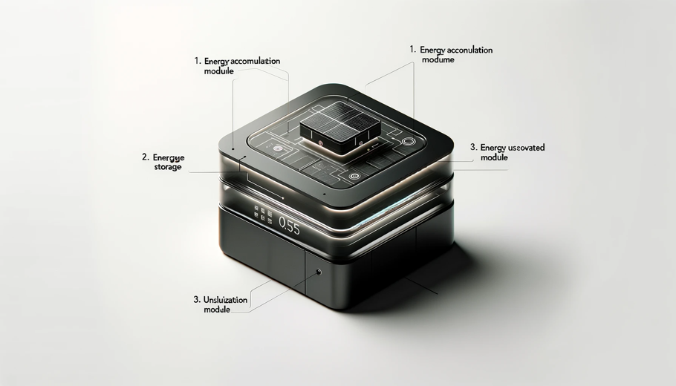

Here is a minimalist and sleek design for an energy harvesting device, incorporating the three key modules you specified: energy accumulation, energy storage, and energy utilization. This design reflects a clean, modern aesthetic, focusing on functionality while avoiding unnecessary details.

**User:**

Based on the information I provided earlier, are there any other details I should provide regarding the design of the energy harvesting device?

**GPT:**

Your initial description for the energy harvesting device design was quite comprehensive, but there are a few additional details you might consider specifying to refine the design further:

1. **Size and Portability**: Indicate the desired size and weight of the device. Should it be portable or stationary?
2. **Energy Source**: Specify the type of external energy source(s) the device will harvest from (e.g., solar, wind, thermal, kinetic).
3. **Power Output and Efficiency**: Define the expected power output range and efficiency levels. How much energy should it store and for how long?
4. **Environmental Conditions**: Describe the environmental conditions (e.g., temperature range, weather resistance) the device needs to withstand.
5. **User Interface and Controls**: Consider if the device needs any user interface elements like displays, buttons, or connectivity features (e.g., Bluetooth, Wi-Fi).
6. **Material Preferences**: Specify any preferred materials for durability, aesthetics, or environmental considerations.
7. **Safety Features**: Outline any necessary safety features, especially if the device will be used in close proximity to people.
8. **Maintenance and Durability**: Provide guidelines for maintenance requirements and desired lifespan of the device.
9. **Budget Constraints**: If there are any cost limitations, mentioning them can help in designing a practical device.
10. **Aesthetic Preferences**: Beyond a minimalist and sleek design, if there are specific color schemes, shapes, or stylistic inspirations you prefer, these can be helpful.
11. **Target Audience or Application**: Clarify if the device is intended for consumer, industrial, or specialized markets.

Adding these details can help in creating a more targeted and functional design for your energy harvesting device.

**User:**

The energy harvesting device is planned to be deployed in a coastal urban environment in Australia. The design needs to take into account the city where it will be applied to ensure consistent energy output throughout the year. Installation must be straightforward. In terms of maintenance, the unit should be designed to minimise the need for frequent repairs and, where necessary, key components should be easily accessible.

The equipment must comply with Australian Standards for Electrical Equipment. The design should be compact to fit into the limited urban space where the installation is specified. Considering the budget of A$50,000, we should prioritise durable materials, balancing cost and longevity.

Based on previous outputs and above information, please give me as many and reasonable and complete designs as possible.

**GPT:**

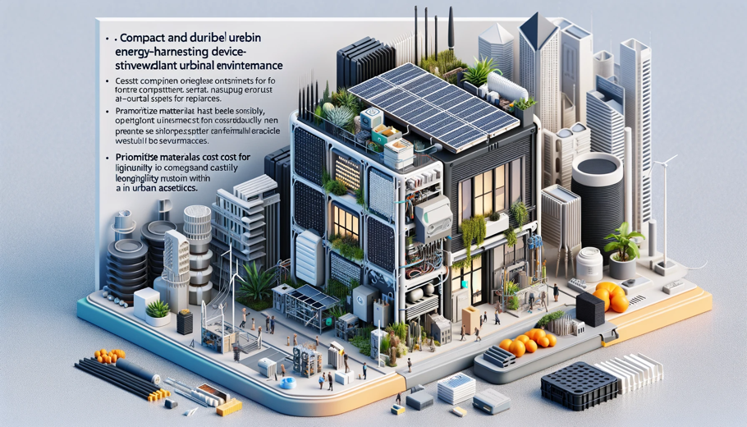

Here is a design for a compact and durable energy harvesting device tailored for a coastal urban environment in Australia. This design considers the requirements for consistent energy output, straightforward installation, minimal maintenance, and compliance with Australian Standards for Electrical Equipment. It's crafted to fit into limited urban spaces and align with your budget considerations.

**User:**

Based on the design you gave me above, please explain each module specifically.

**GPT:**

The design of the energy harvesting device, tailored for a coastal urban environment in Australia, features three key modules, each with specific functions:

1. **Energy Accumulation Module**:
   * This module is responsible for deriving energy from external sources. Considering the coastal urban setting in Australia, this module might utilize solar panels, wind turbines, or other methods suitable for the local environment.
   * The design ensures this module is exposed to the environment to maximize energy capture. For example, solar panels could be strategically positioned to catch the maximum amount of sunlight throughout the year.
   * The module's design is robust to withstand coastal weather conditions, such as high humidity, salt spray, and variable temperatures.
2. **Energy Storage Module**:
   * This part of the device stores the energy accumulated from external sources. It likely includes batteries or other energy storage technologies.
   * The design considers the need for high-capacity storage to ensure a consistent energy supply, even when the primary energy source (like sunlight or wind) is not available.
   * The module is integrated in a way that protects the storage components from environmental factors and urban conditions. It's also designed to be compact, fitting into limited urban spaces without compromising on storage capacity.
3. **Energy Utilization Module**:
   * This module is where the harvested energy is converted and regulated for use in powering other devices, such as sensors, heating/cooling systems, or actuators.
   * It includes the necessary electronic circuitry for managing the energy output, ensuring that it's compatible with the devices it powers.
   * The design likely features connectivity options (such as wireless communication) to facilitate integration with other urban infrastructure or for remote monitoring and control.

Overall, the design of each module emphasizes durability, efficiency, and compliance with Australian Standards for Electrical Equipment. It balances the need for energy efficiency and output consistency with the requirements of a coastal urban environment, including considerations for ease of installation, minimal maintenance, and component accessibility for repairs when necessary. The use of materials and construction techniques focuses on longevity and resistance to environmental factors, all within the specified budget constraints.